Three methods for identifying

time constants

TNG022

Ludvig Kratzert

2018-11-29

Instructor: Kjell Karlsson

**Introduction**

A time constant is a measure of how quickly a system approaches a target state. A small time constant indicates that the system can change its state quickly while a large time constant implies that the system changes slowly. The time constant is an important measurement in automatic control.

In this lab the system in question is a DC motor. The DC motor has two subsystems: an electrical part and a mechanical part. These subsystems have their own time constants, τ *e* and

* *m* , but there also exists a time constant τ *tot* *​*for the entire motor.

The time constant of a system can be determined in several different ways. The purpose of this lab is to use and compare three different methods: A computer-aided experimental method, an analytical method and simply checking the values given by the manufacturer.

The scope of this lab is limited with regards to the particular implementation; the primary focus is the general methods for determining the time constants.

**Methods and materials**

The experimental method had three steps: First, a model of the system was made on paper. This was done using some well known properties of DC motors and a sketch of the system, provided in the lab PM. It also required all physical constants to either be calculated or found in the data table given by the manufacturer. Second, said model was implemented in a simulation software. This implementation is seen in figure 1.

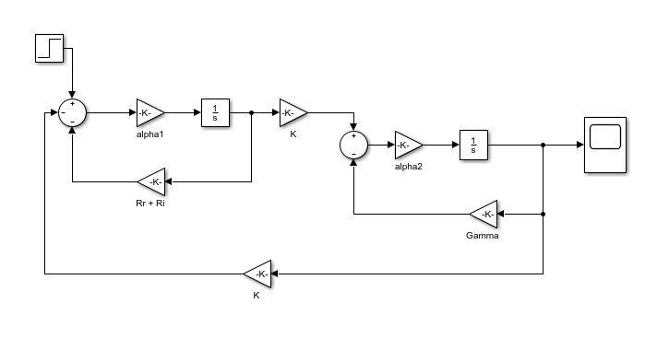

*Figure 1: The model implemented in software*

Third, three simulations of step responses were run, two for the subsystems and one for the whole motor. Simulating the step response of a subsystem was done by moving the input and output signals to different points on the model. For example, the

mechanical step response was simulated by moving the input to the start of the mechanical part of the system and moving the output to the end of the mechanical part of the system. Once the step responses had been found, the time constants were calculated by finding the time at which each step response reached 63% of its final value. This is the definition of the time constant. The measurement was made by manually moving the cursor along the step response and reading the values. An example of a step response is shown in figure 2.

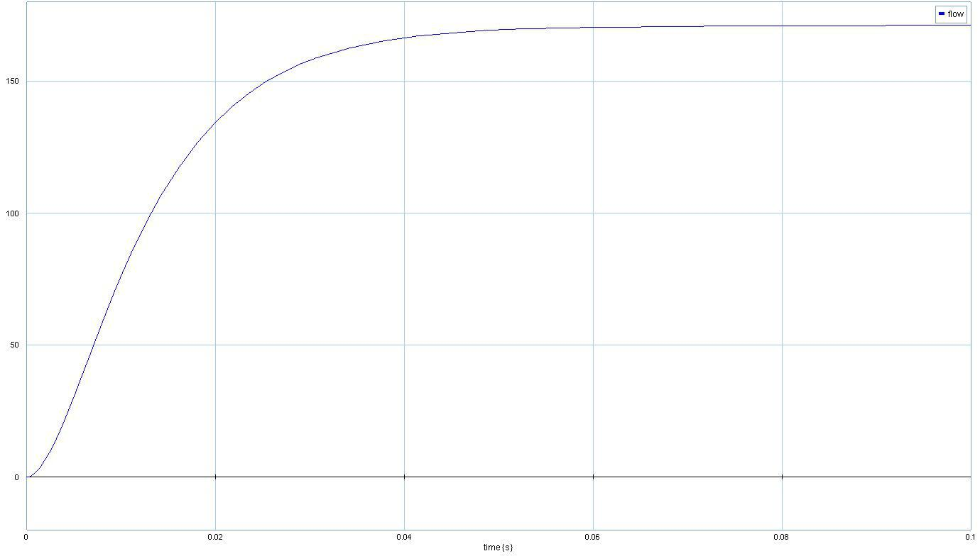

*Figure 2: A computer-generated step response.*

The analytical method also used the on-paper model of the system. By looking at each of the subsystems, two transfer functions were composed. By rearranging these transfer functions to the form of equation 1, the time constants were found.

|  |  |  |  |
| --- | --- | --- | --- |
| *G*(*s*) = | *K* | ​(1) |  |
| τ *s* + 1 |  |



It was not possible to find a value for τ *tot* analytically as this would require a transfer

function for the entire system. Finding such a transfer function is possible but since its denom-inator would be at least second order we would not be able to write it in the form of equation 1.

The third method was to look at the time constants given by the manufacturer. The data provided by the manufacturer is found in appendix

1. This data sheet has values for τ *tot* *​*and τ *e* but not τ *m* .

**Results and discussion**

The time constants that resulted from the three different methods are found in table 1 below.

1

*Table 1: Time constants from the different methods*



|  |  |  |  |
| --- | --- | --- | --- |
|  | Experimental | Analytical | Manufacturer |
|  |  |  |  |
| τ *tot* | 14,2 ms | – | 10,2 ms |
| τ *m* | 0,32 s | 0,32 s | – |
|  |  |  |  |
| τ *e* | 2,93 ms | 2,95 ms | 2,95 ms |
|  |  |  |  |

As table 1 shows, the different methods yielded very similar results for τ *m* and τ *e* . However, the value of τ *tot* differs greatly between the experimental method and the value given by the manufacturer.

We would like for the values from the different methods to be as similar as possible. Since the values from the experimental and analytical methods are derived from constants given by the manufacturer, it is to be expected that all methods should produce similar values. Thus, the big difference in τ *tot* is unexpected. This difference might be due to a modelling error. It is possible that some physical property of the system has been neglected in our model and that this property is responsible for the large time constant compared to that given by the manufacturer.

It is also possible that there has been an error in measurement. In the last step of the experimental method, the time constant is measured manually by moving the cursor along the step response. This opens up for human error. Measurement error might also be the reason for the small difference in τ *e* between the experimental method and the other two.

The three methods all have benefits and drawbacks. The method of looking at the manufacturer’s data has the benefit of being both fast and simple. Its main drawback is that it does not provide us with a value for τ *m* . This method also requires that we trust the manufacturer. However, so do the other two methods as they also rely on values given by the manufacturer. It would be preferable to measure everything ourselves but that would be beyond the scope of this lab.

The analytical method uses the values given by the manufacturer in conjunction with some well known properties of DC motors (given in the lab PM) to construct a model of the system. From this model the time constants are derived though calculations. Because of this, the time

constants can never be more accurate than our model of the system. Any false assumption or neglected property of the system may cause the model to exhibit behaviours that are not representative of the real system and thus produce faulty time constants. In this way, the analytical approach is prone to error. When used correctly though, it is both fast and accurate.

The experimental approach also uses the model of the system. It is therefore prone to the same errors as the analytical approach. Furthermore, since it involves manually measuring the time constant, it opens up for more human error. It also takes time to implement the model in the software. The main benefit of this method is that it, uniquely, allows us to calculate all three time constants. It also gives deeper insight into the system as it provides a complete step response.

**Conclusion**

The results of this lab show that the three different methods produce similar results for τ *e* . The values of τ *m* from the analytical and experimental methods are also similar. The only discrepancy is that the value of τ *tot* from the experimental method and the manufacturer differ significantly. This difference implies three possibilities: the manufacturer is wrong, the experimental method produces faulty values or there are errors both with the manufacturer and the experimental method.

The three methods have advantages and disadvantages. Looking at the manufacturer’s data is the fastest method and the experimental method is the slowest. The experimental method produces values for all three time constants while the analytical method and the manufacturer​*​*omit τ *tot* and τ *m* , respectively.

In conclusion, none of the methods alone can reliably provide correct values for all time constants. Using the three methods together and comparing the results improves our likelihood of finding correct values for the time constants.

2

**Appendix**

Information about the system given by the manufacturer. Note that “Mechanical time constant” designates τ *tot* *.*

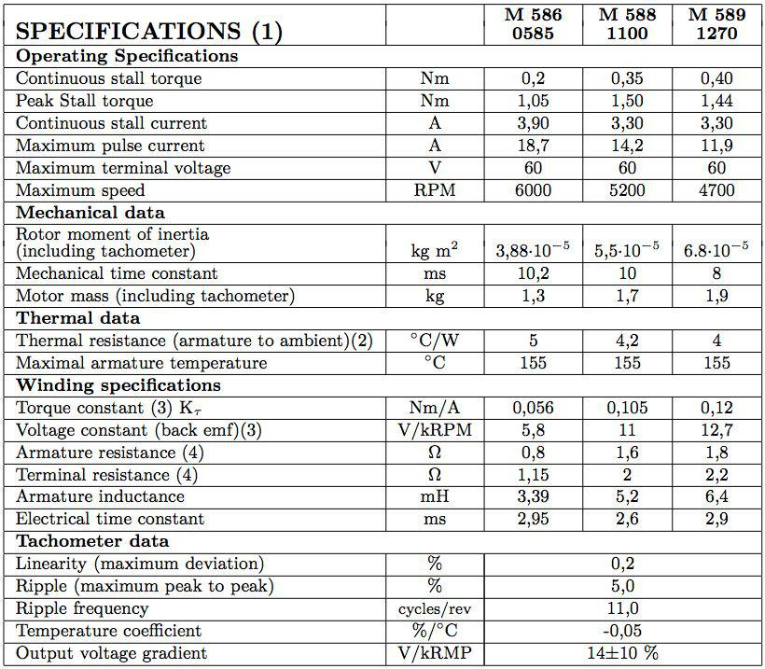

3